**Amazon EC2 Linux Instances**

Amazon Elastic Compute Cloud (Amazon EC2) is a service of AWS and here we are launching Linux instance. An instance is a virtual server in the AWS cloud. With Amazon EC2, you can set up and configure the operating system and applications that run on your instance.

Here are some steps below to Launch EC2 instance on AWS..

**To launch an EC2 instance**

1. **Sign in to the AWS Console**
2. **Open the Amazon EC2 console by choosing EC2 under Compute.**

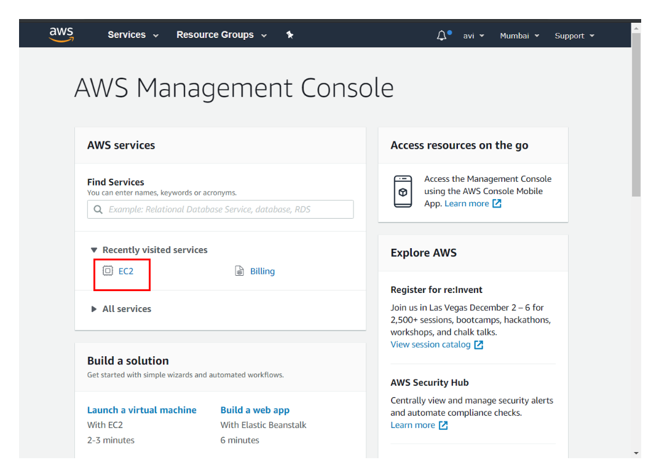

**3**. **From the Amazon EC2 dashboard, choose Launch Instance.**

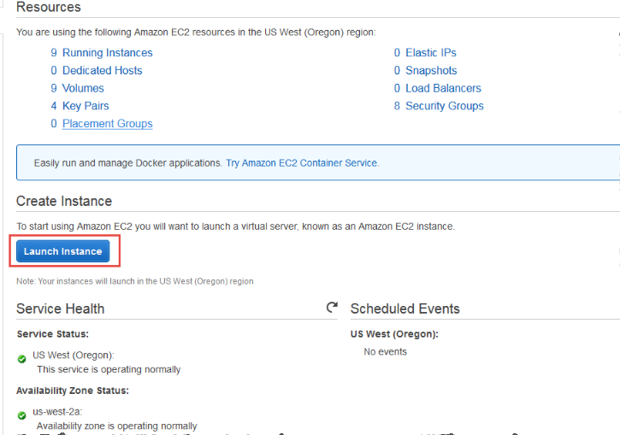

**4. The Choose an Ubuntu Server 18.04 LTS (HVM), (AMI) page displays a list of basic configurations called Amazon Machine Images (AMIs) that serve as templates for your instance. Select the HVM edition of the Amazon Linux AMI. Insure that this configuration is marked as Free tier eligible.**

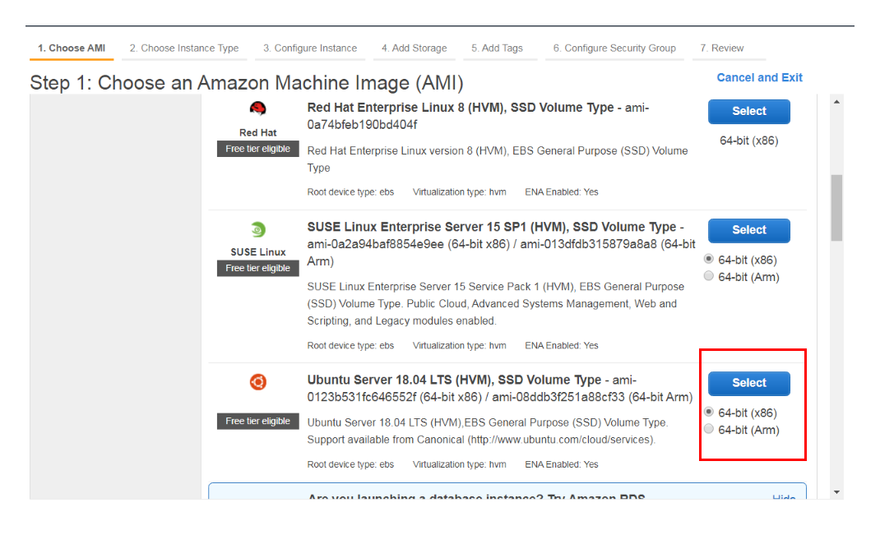

**5. Configure the instance to suit your requirements. You can launch multiple instances from the same AMI By just Mentioning there,** **You can create a New VPC(Virtual Private Cloud) or use Default one which AWS created automatically for your Instance**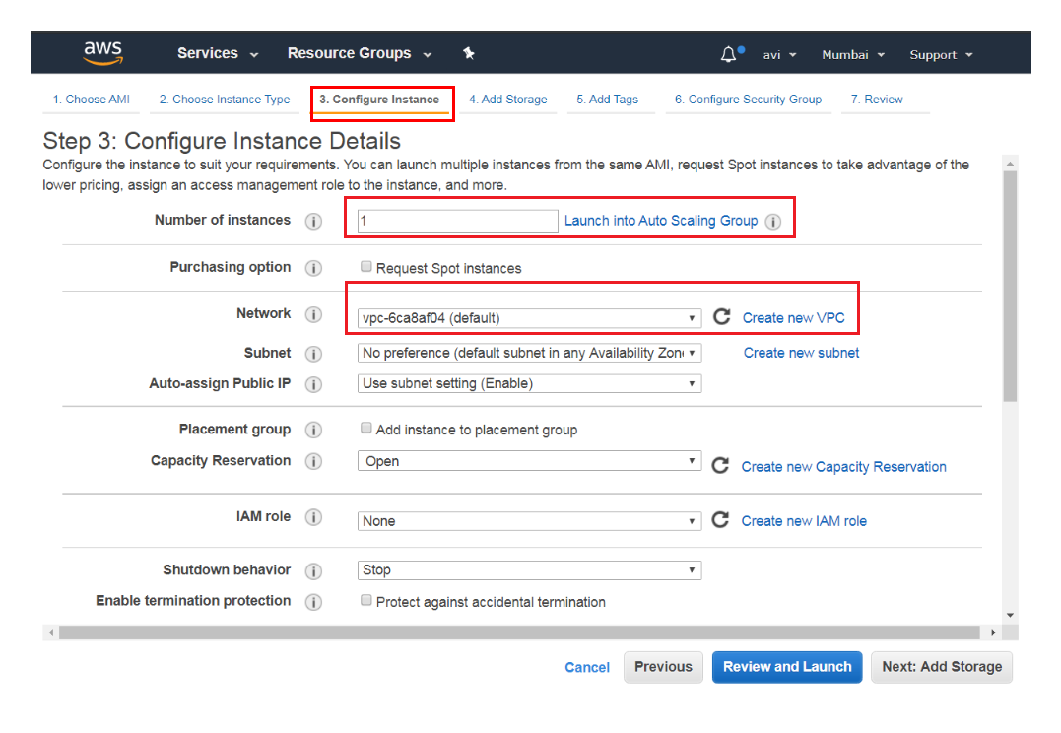

**7. Add Storage for Your Instance By Simply increasing the Gig size which is given below. And click on Review and Launch**

**Note - Only 30gig of storage are available in free tier of HVM.**

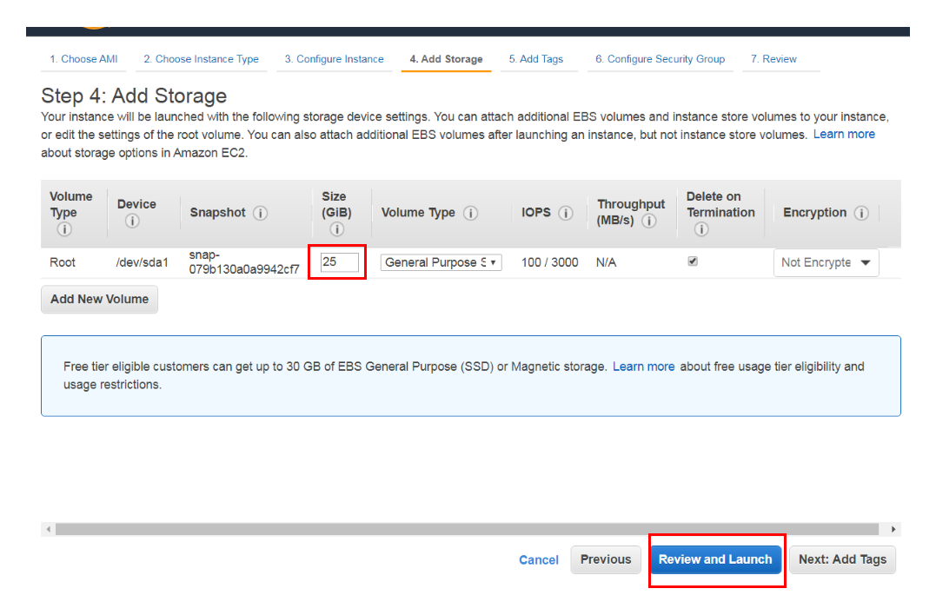

**8.**  **Configure Security Group A security group is a set of firewall rules that control the traffic for your instance.** **You can add rules to allow specific traffic to reach your instance. For example, if you want to set up a web server and allow Internet traffic to reach your instance, add rules that allow unrestricted access to the HTTP and HTTPS ports. You can create a new security group or select from an existing one below.**

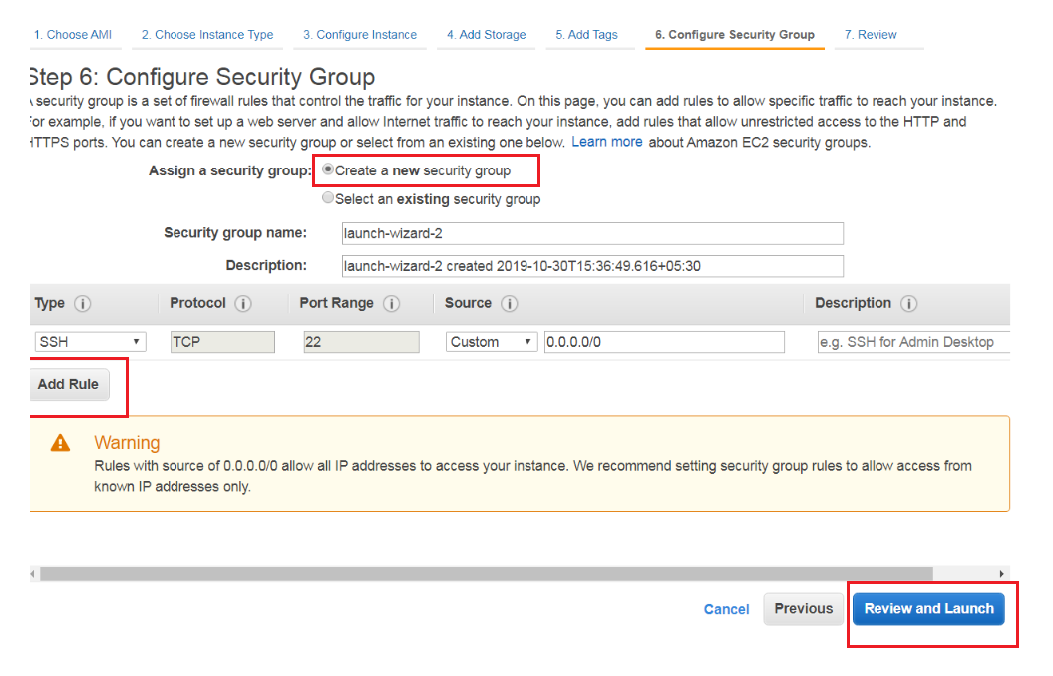

**9. Now Review your instance launch details. You can go back to edit changes for each section. Click Launch to assign a key pair to your instance and complete the launch process.**

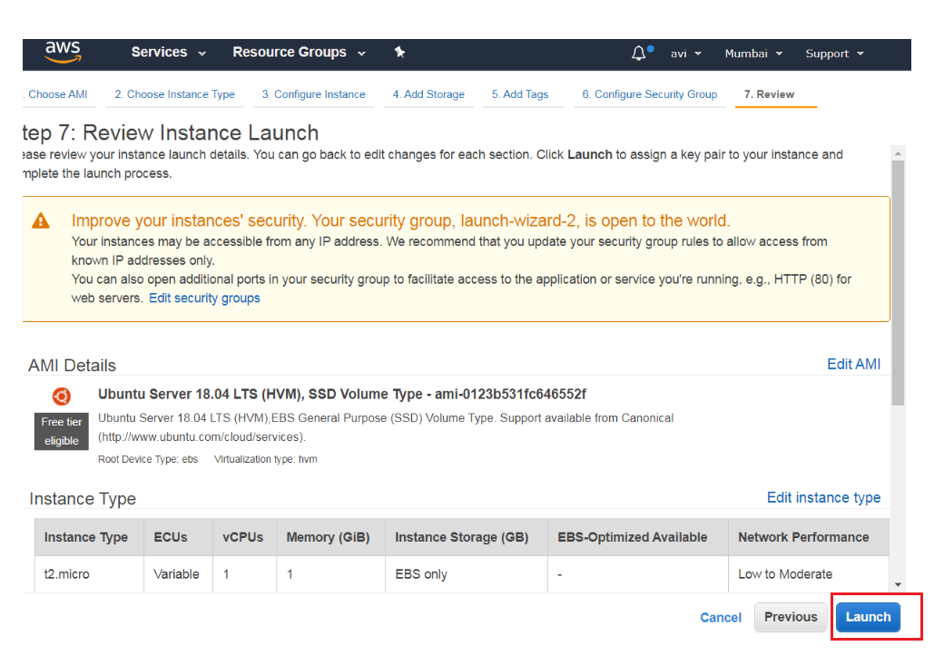

**10. Pair Key A key pair consists of a public key that AWS stores, and a private key file that you store.**  **they allow you to connect to your instance securely.**  **For Linux AMIs, the private key file allows you to securely SSH into your instance.**

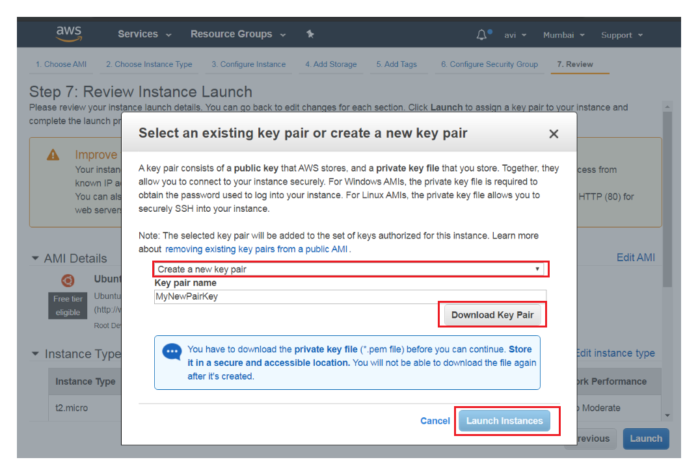

# Connect to Your Amazon EC2 Instance

# Now that you have launched your EC2 instance, you can connect to it and use it the way that you'd use a computer

## Connect from Windows using PuTTY

**PuTTY uses .ppk files instead of .pem files. If you haven't already generated a .ppk file, do so now.**

1. **Start PuTTYgen (for example, from the Start menu, choose All Programs > PuTTY > PuTTYgen).**
2. **Under Type of key to generate, choose RSA.**
3. **Choose Load. By default, PuTTYgen displays only files with the extension .ppk. To locate your .pem file, select the option to display files of all types.**
4. **Select the private key file that you created in the previous procedure and choose Open. Choose OK to dismiss the confirmation dialog box.**
5. **Choose Save private key. PuTTYgen displays a warning about saving the key without a passphrase. Choose Yes.**
6. **Specify the same name for the key that you used for the key pair. PuTTY automatically adds the .ppk file extension.**
7. **Copy AWS EC2 Instance Ipv4 Public Ip**
8. **Open PuTTy And Paste EC2 Instance public Ip**
9. **Go to auth option And add Your .ppk file**
10. **If this is the first time you have connected to this instance, PuTTY displays a security alert dialog box that asks whether you trust the host you are connecting to. Choose Yes. A window opens and you are connected to your instance.**

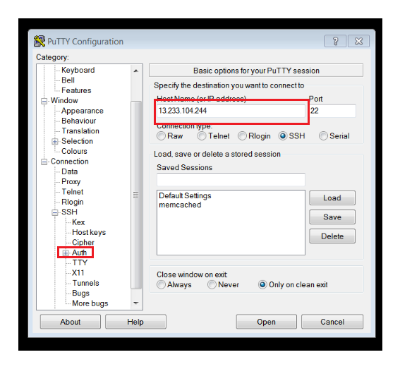

# Now You Are Good to Go You can Access Your Instance Through ssh.

# 

# 